#mọi người lưu ý là nhập trong đây nha

#ai có ý gì thì cứ ghi vào nha, xóa hay gì thì báo cho mọi người trước

#tìm tài liệu nhớ copy link nguồn nha mọi người :3

#mọi người cố lên <3 from Nguyên :3

--------------------------------------------------------------------------------------------------------

**1.About Xiaomi**

* Xiaomi Corporation is a multinational electronics firm based in China that was founded in April 2010. Xiaomi manufactures and invests in a wide range of products, including smartphones, mobile apps, laptops, home appliances, and more. After Apple, Samsung, and Huawei, Xiaomi is the fourth firm in the world with self-developed mobile phone chip capabilities, with roughly 291.6 million customers worldwide.

**2.Name, tagline, logo**

* The word 'Xiaomi' translates to 'Millet' or 'Rice.' Lei Jun associates the term "Xiao" with the Buddhist concept. The company's logo features the word 'Mi' written in white inside an orange rectangle. Stands for "Mobile Internet" or "Mission Impossible," and represents all of the company's previous challenges.

**3. Timeline Xiaomi:**

* On April 6, 2010, eight partners co-founded Xiaomi.
* Xiaomi officially launched the first Android-based MIUI software on August 16, 2010. The Xiaomi Mi1 smartphone was released in August 2011. It is powered by MIUI software and is available in Australia, Europe, New Zealand, the United Kingdom, and the United States as of September 24, 2013.
* September-October 2013, Xiaomi is said to be China's fifth most popular smartphone brand.
* Xiaomi announced their first stop outside of China in 2014, with Singapore as their first stop. The Xiaomi Redmi and Mi3 smartphones were released in Singapore on February 21 and March 7, 2014, respectively.
* After Singapore, the company expanded to Malaysia, the Philippines, and India, with plans to expand further.
* Xiaomi completed an equity round of an investment fund that raised more than US$1 billion in December 2014, at a price of more than US$45 billion, making it one of the world's largest IT companies.

4. Comes to Vietnam:

* Xiaomi officially announced on their Facebook fanpage that they will open a market in Vietnam on March 15, 2014 in HCM city, following the opening of their first store in Singapore.
* Xiaomi also unveiled three new smartphones at this event: the Redmia 4A, the Redmi Note 4, and the Mi Mix. Two of them were priced in the middle. Three of the most recent models are available in both Vietnamese and 4G. They also established four Xiaomi Warranty Centers (1 in HN and 1 in DN, 2 in HCM).

5. CEO’s history:

* “Just for fan” is the slogan of Xiaomi in Vietnam
* "We want to give Vietnamese people the option to have fantastic experiences and improve their quality of life through connectivity by providing a product that is completely superior to similar items sold at the lowest price." with the help of technology

Link: -<https://hoanghamobile.com/tin-tuc/xiaomi-chinh-thuc-gia-nhap-thi-truong-viet-nam-vao-ngay-153-toi>

-<https://startuptalky.com/xiaomi-success-story/>

--------------------------------------------------------------------------------------------------------

Phương Anh:

1.Highlights:

* Xiaomi phones have a 12% share of the domestic smartphone market, ranking third behind the names like Samsung and Oppo.
* First Chinese phone brand to open manufacturing plant in Vietnam
* Low-price phone product, strong configuration
* Xiaomi is the only brand can maintain growth among anothers phone brand in Vietnam even in the pandemic
* Xiaomi joins volunteer events in south Vietnam even it affected by Covid-19

2.Oppotunities:

* (Cái này Như làm sơ đồ chẻ nhánh nha, mấy từ tui in đậm á)

**Owning a factory** in Vietnam with **low-salary employees**, shortening **delivery time and transportation costs**, avoiding **import tax barriers**

* **Suitable consumers: Students, middle-income workers (sơ đồ nhỏ )**

3.Smartphone vendors ranking

2019

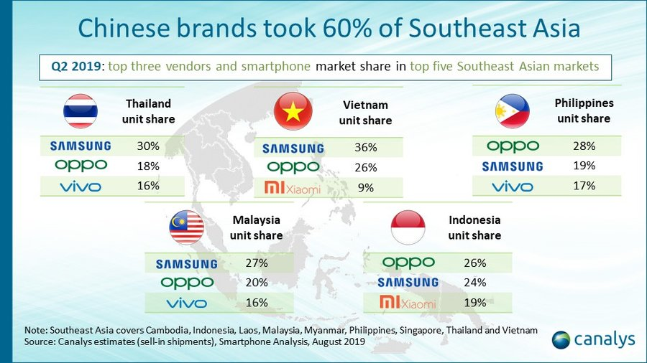

2020

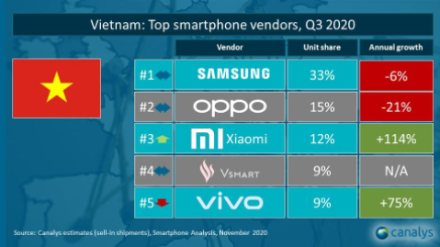

2021

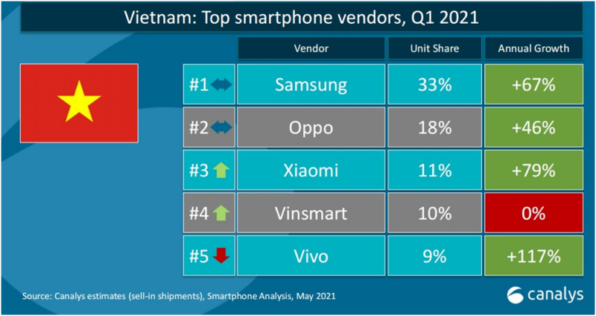

Reference: https://www.canalys.com/insights/The-driving-forces-behind-the-high-growth-South-Asian-smartphone-markets

--------------------------------------------------------------------------------------------------------

Thông:

Marketing strategy:

1. Prices: worth every single penny

· High experience with reachable price – purchasing preference of the Vietnamese.

2. Performance and design

· Gaming market is significantly advancing - Met the demand of Vietnamese users - low Price of smartphone products

· Aim to the insight of gen z – upgrade their phone mainly to the camera – high quality photos, videos.

3. Diversity of devices: phone, TV, smart watch or earphones and so forth.

· Common in various areas

4. Services:

· Customer service: leveraging social media platforms beautifully to enhance their online presence.

· Mi Store: unlike the top two brands ( samsung, apple ) – opening first store after 10 months in Vietnam market – customers easily hand in hand Xiaomi products – unforgettable experience.

Link:

<https://www.themarcomavenue.com/blog/how-xiaomi-is-dominating-the-global-smartphone-market/>

<https://insideretail.asia/2018/01/08/mi-store-vietnam-opens/>

<https://influencerviet.com/blog/2019/08/22/chien-dich-quang-cao-quai-kiet-chup-hinh-%ef%bb%bfxiaomi-redmi-note-5/>